Preparation of Manuscript for Journal of Telecommunication, Electronic & Computer Engineering (JTEC)

A.Author^{1, 2}, B.Author2², C.Author3³ and D.Author4³
¹Affiliation 1. (Numbered for more than 1 affiliation, otherwise not required)
²Affiliation 2.
³Affiliation 3.
main_author@email.com

Abstract—This electronic document is the template for the manuscript for Journal of Telecommunication, Electronic & Computer Engineering (JTEC). All contents should be replaced by the real materials but do not change the format here. This template must be strictly followed in order for the manuscript to be considered for publication in JTEC

Index Terms—About; Four Key Words or Phrases; In Alphabetical Order; Separated by Semicolon.

Introduction

The Journal of Telecommunication, Electronic and Computer Engineering (JTEC) (ISSN 2180-1843, eISSN 2289-8131) is a refereed journal published by Universiti Teknikal Malaysia Melaka.
High-quality papers for Journal of Telecommunication, Electronic and Computer Engineering, are now invited for submission. Interested authors should read the ‘Instructions to Authors’ section for all details of requirements, procedures, paper mechanics, referencing style, and the technical review process for submitted papers.
Papers should be submitted online through JTEC Online Submission at http://journal.utem.edu.my/index.php/jtec/ and other requirements should be followed as in the Instructions to Authors. There will be no strict publication schedule. As soon as they are ready, successful papers will be posted in sequence in the JTEC.

Manuscript Preparation

The manuscript article should be written in English in the font of Times New Roman, which includes the following: abstract, introduction, literature review, objectives, research methodology, theory, testing and analysis, results and discussions, conclusion, acknowledgement and references. Manuscript should be prepared via the Microsoft Word processor.

Title, Authors Name & Affiliation
The manuscript title should be centered across the full page with the first letter of each major word in capital letters. Title should be typed using 24-font size, Times New Roman. Author name(s) should be typed using 11-font size, Times New Roman. Author(s) affiliation and address information should be Italic in 10-font size, Times New Roman.

Figures, Tables, Charts & Diagrams
Figures, tables, charts & diagram should be kept to a minimum. They can be in black and white with minimum shading or colored with high visibility. Do not use color unless it is necessary for the proper interpretation of your figures. If you want reprints of your color article, the reprint order should be submitted promptly and numbered consecutively. They should have a brief title/caption in a font size of 8.
The table contents should be typed in single spacing, 8-font size, Times New Roman.

C_{L}
C
L
L

Figure 1: Black and white figure

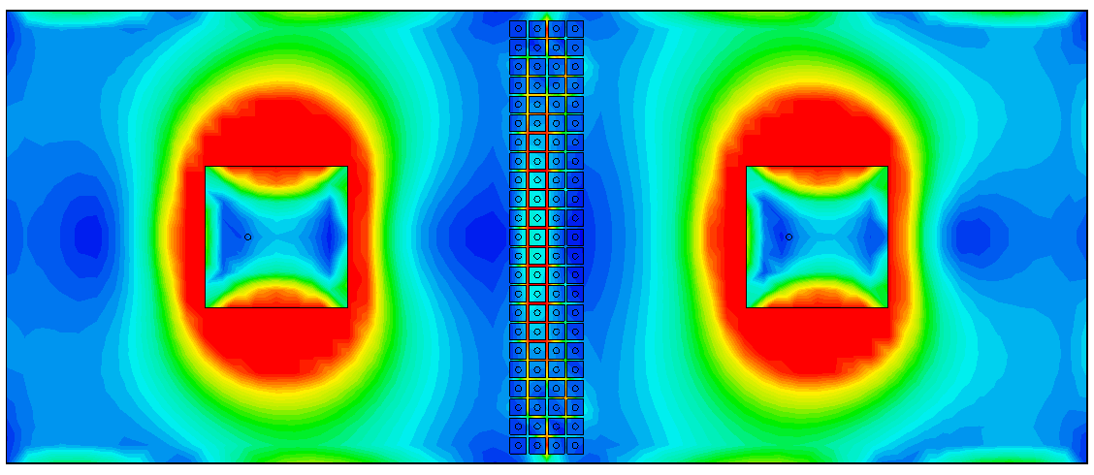

Figure 2: Colored figure

Math And Equation

If you are using Word, use either the Microsoft Equation Editor or the MathType add-on for equations in your paper “Float over text” should not be selected.

Equations
Number equations consecutively with equation numbers in parentheses flush. First use the equation editor to create the equation. Use the table format as shown below:

(1)
(2)

where: F = External force
m = Mass of the object
a = Acceleration of the object
$f_{c}=\frac{1}{2π\sqrt{{LC}_{tot}}}$
Be sure that the symbols in your equation have been defined before the equation appears or immediately following. Italicize symbols (T might refer to temperature, but T is the unit tesla). Refer to the equation as “Equation (X)” where X is the equation number.

Units

Use SI as primary units. English units may be used as secondary units (in parentheses). For example, write “15 Gb/cm² (100 Gb/in²).” An exception is when English units are used as identifiers in trade, such as “3½-in disk drive.” Avoid combining SI and CGS units, such as current in amperes and magnetic field. This often leads to confusion because equations do not balance dimensionally. If you must use mixed units, clearly state the units for each quantity in an equation.
The SI unit for magnetic field strength H is A/m. However, if you wish to use units of T, either refer to magnetic flux density B or magnetic field strength symbolized as µ₀H. Use the center dot to separate compound units, e.g., “A·m².”

Table 1
Units for Magnetic Properties

Symbol | Quantity | Conversion from Gaussian and  CGS EMU to SI ª
Φ | magnetic flux | 1 Mx → 10⁻⁸ Wb = 10⁻⁸ V·s
B | magnetic flux density,  magnetic induction | 1 G → 10⁻⁴ T = 10⁻⁴ Wb/m²
H | magnetic field strength | 1 Oe → 10³/(4π) A/m
m | magnetic moment | 1 erg/G = 1 emu  → 10⁻³ A·m² = 10⁻³ J/T
4πM | magnetization | 1 G → 10³/(4π) A/m
σ | specific magnetization | 1 erg/(G·g) = 1 emu/g → 1 A·m²/kg
N, D | demagnetizing factor | 1 → 1/(4π)

Manuscript Format

Page Limit
The number of page for the manuscript may vary from minimum of 4 pages to the maximum of 10 pages in A4 size. Authors are required to strictly advise to adhere to this limit. Manuscript with less than 4 pages or exceeding 10 pages may be unable to be included in the Journal.

Margin
The manuscript should be within the print area with margin of 0.7 inches top and bottom; and 0.65 inches for left and right margin. Page number should appear at the bottom right of the odd pages and bottom left of the even pages of the manuscript.

Text
The body of the manuscript should be typed in double column (column width = 3.38 inches and column spacing 0.2 inches), single spacing, 10-font size, Times New Roman, printed on one side of the sheet. Section headings should be typed in 10-font size, Times New Roman, centered in the column with small cap effects and each of the word is capitalized. Sections should be numbered consecutively.

Figures Format
Format and save your graphic images using a suitable graphics processing program that will allow you to create the images as PostScript (PS), Encapsulated PostScript (EPS), or Tagged Image File Format (TIFF), sizes them, and adjusts the resolution settings. If you created your source files in one of the following you will be able to submit the graphics without converting to a PS, EPS, or TIFF file: Microsoft Word, Microsoft PowerPoint, Microsoft Excel, or Portable Document Format (PDF).

References
References should be numbered and cited within the square brackets in order of appearance in the text. Example of references can be from books, journal publication, conference proceedings and websites. A list of references should be listed at the end of the manuscript. No footnotes are allowed. The references should be typed in single spacing, 8-font size, Times New Roman.

Conclusion

A conclusion to review the main points of the paper, do not replicate the abstract as the conclusion. A conclusion might elaborate on the importance of the work or suggest applications and extensions.

Appendix

Appendixes, if needed, appear before the acknowledgment.

Acknowledgment

Sponsor and financial support acknowledgments can be mentioned here.

References

- G. O. Young, “Synthetic structure of industrial plastics (Book style with paper title and editor),” in Plastics, 2nd ed. vol. 3, J. Peters, Ed. New York: McGraw-Hill, 1964, pp. 15–64.
- W.-K. Chen, Linear Networks and Systems (Book style). Belmont, CA: Wadsworth, 1993, pp. 123–135.
- H. Poor, An Introduction to Signal Detection and Estimation. New York: Springer-Verlag, 1985, ch. 4.
- B. Smith, “An approach to graphs of linear forms (Unpublished work style),” unpublished.
- E. H. Miller, “A note on reflector arrays (Periodical style—Accepted for publication),” IEEE Trans. Antennas Propagat., to be published.
- J. Wang, “Fundamentals of erbium-doped fiber amplifiers arrays (Periodical style—Submitted for publication),” IEEE J. Quantum Electron., submitted for publication.
- C. J. Kaufman, Rocky Mountain Research Lab., Boulder, CO, private communication, May 1995.
- Y. Yorozu, M. Hirano, K. Oka, and Y. Tagawa, “Electron spectroscopy studies on magneto-optical media and plastic substrate interfaces (Translation Journals style),” IEEE Transl. J. Magn.Jpn., vol. 2, Aug. 1987, pp. 740–741 [Dig. 9th Annu. Conf. Magnetics Japan, 1982, p. 301].
- M. Young, The Techincal Writers Handbook. Mill Valley, CA: University Science, 1989.
- J. U. Duncombe, “Infrared navigation—Part I: An assessment of feasibility (Periodical style),” IEEE Trans. Electron Devices, vol. ED-11, pp. 34–39, Jan. 1959.
- S. Chen, B. Mulgrew, and P. M. Grant, “A clustering technique for digital communications channel equalization using radial basis function networks,” IEEE Trans. Neural Networks, vol. 4, pp. 570–578, Jul. 1993.
- R. W. Lucky, “Automatic equalization for digital communication,” Bell Syst. Tech. J., vol. 44, no. 4, pp. 547–588, Apr. 1965.
- S. P. Bingulac, “On the compatibility of adaptive controllers (Published Conference Proceedings style),” in Proc. 4th Annu. Allerton Conf. Circuits and Systems Theory, New York, 1994, pp. 8–16.
- G. R. Faulhaber, “Design of service systems with priority reservation,” in Conf. Rec. 1995 IEEE Int. Conf. Communications, pp. 3–8.
- W. D. Doyle, “Magnetization reversal in films with biaxial anisotropy,” in 1987 Proc. INTERMAG Conf., pp. 2.2-1–2.2-6.

